SPRED
A publication of Special Religious Development Volume 101 | Number 9 | May 2022
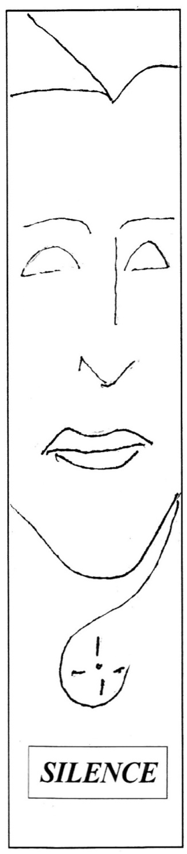
The human experience of silence has become increasingly rare over the
years and decades. The cacophony of sounds can be startling when we are unaccustomed to noise in our environment. It can jangle our nerves. Yet, how quickly we adapt and consider it to be a normal part of everyday life. My home in Chicago is close to busy railroad tracks and on the flight path to Midway Airport less than five miles distant. Most days are filled with the sounds of planes, trains and automobiles. Yet, sometimes late at night or early on a Sunday, the neighborhood is blissfully quiet. It didn’t take long for me to learn how to ignore these intrusive noises. I only notice when they interrupt my talking or my listening. Yet do I really block out all the effects of noise? Does it still jangle my nerves in less obvious ways?
When we do encounter silence, there is often some discomfort or awkwardness associated with it. We feel as if we should fill the silence with television or radio or our own voice. Furthermore, when we do encounter silence, we may feel we are somehow wasting our time or doing nothing. Can we be comfortable with the idea of doing nothing for an extended period of time and letting the silence wash over our being?
Two contemporary writer-observers express some hope that we will eventually recognize our need for quiet.
Gordon Hempton describes himself as an acoustic activist. He thinks of unwanted man-made sounds as noise pollution. “It’s so exciting to be alive today...because we are making these choices rather than living a life of assumptions where quiet is not important. Not too long ago, it was assumed that...clean water is not important—but now it is, and we’re cleaning that up... And now I think we’re realizing quiet is important, and we need silence: that silence is not a luxury, but it’s essential. It’s essential to our quality of life and being able just to think straight.” ¹
Pico Iyer notes that the wisdom of quietude can be traced at least as far back as the 17th century when French philosopher Blaise Pascal famously remarked that all of man’s problems come from his inability to sit quietly in a room alone. Iyer comments “Nothing makes me feel better—calmer, clearer and happier— than being in one place, absorbed in a book, a conversation, a piece of music. It’s actually something deeper than mere happiness: it’s joy.” ²
Our religious traditions have historically valued silence in prayer and liturgy to some extent, although that has perhaps eroded over the centuries. At one time, my parish would intentionally structure silent periods of 30–60 seconds after each reading, the homily and communion—no music, no ritual action, just sitting in silence. Sadly, that tradition has been lost over the past several years.
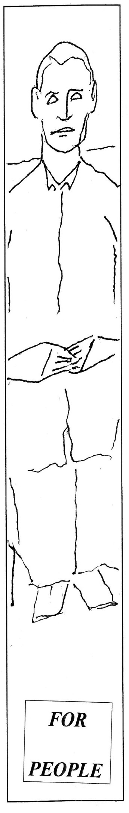
The mystery of God’s presence among us is wrapped in silence. Pope Francis told a congregation at the morning Mass on December 20, 2013 that Christians should seek “the grace to love silence.” “Each of us knows how mysteriously the Lord works in our hearts, in our souls,” the Pope said. “Silence is that which guards the mystery.” ³
In the Gospels, Jesus’ seeking solitude and prayer in a quiet place speaks louder to us than all the books that have been written on prayer and praying.
Mt 14:22-23 – Then Jesus made the disciples get into the boat, while he dismissed the crowds. After doing so, he went up on the mountain by himself to pray. When it was evening he was there alone. (Also Mk 6:45-46)
Mk 1:35-37 – Rising very early before dawn, Jesus left and went off to a deserted place, where he prayed. Simon and those who were with him pursued him and on finding him said, “Everyone is looking for you.”
Lk 5:15-16 – The report about Jesus spread all the more, and great crowds assembled to listen to him and to be cured of their ailments, but he would withdraw to deserted places to pray.
Jn 6:15 – Since Jesus knew that they were going to come and carry him off to make him king, he withdrew again to the mountain alone.
Silence is more than the absence of sound. In fact, silent reflection often includes the background of music or nature. Sitting silently with another does not preclude all communication. Eyes and body posture and gestures can communicate many things—especially feelings. Silence enhances attention and presence. Silence and reflection can lead one to value mystery and being. Our society values knowledge and doing—often excluding or crowding out the values of mystery and being.
SPRED was born with a built-in bias towards silence—and it is structured
into various parts of the catechist preparation session and total community sessions. In our catechist preparation sessions, we begin with reading a literary selection. After the reading, a synopsis and a question or two lead us into twenty minutes of silent reflection—with instrumental background music.
The duration of time is necessary, as busy adults in a hectic world, to slow down and form a meaningful and personal response to the question in line with the goal of the session. We offer our singular experience, in rich detail and with the human feelings/memories/mystery which have been evoked in us, as a gift to our adult SPRED companions. We have come to value that quiet period and the subsequent sharing as the primary element of bonding of catechists to each other as a faith community.
In the total community sessions, observers often remark on the limited interactions between helper catechist and their friend sitting next to them. Instead, the setting is one of quiet and focuses on activity and choice of activity. Again, the time is needed, as busy adults and friends with other abilities, to slow down and prepare to listen and engage in SPRED catechesis. While there may be very few spoken words between catechist and their special friend, it would be incorrect to say there is no communication and no bonding happening. The shared work that each has chosen becomes a medium of communication and bonding and a prepared grounding for the session.
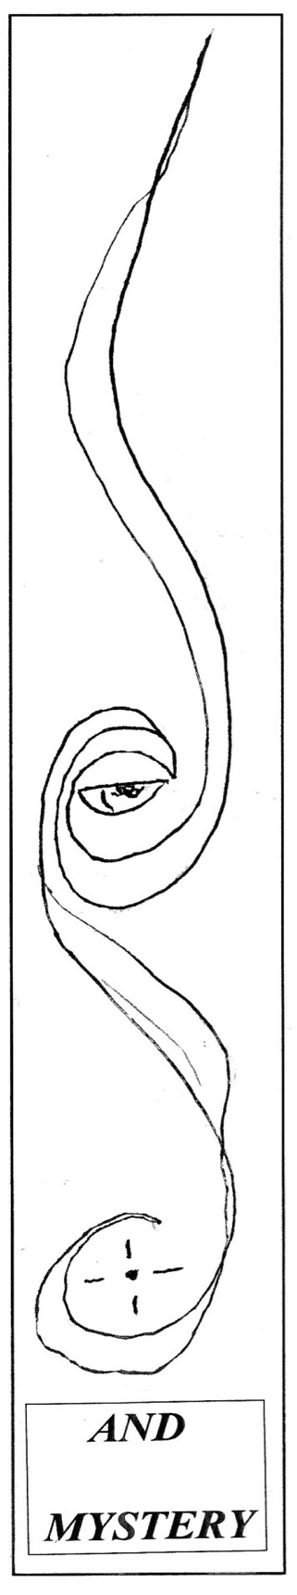
In each session, another period of cherished silence occurs after the personal expression—consisting of a song or psalm with sacred gestures. Everyone sits quietly while the leader catechist plays a classical instrumental music for a minute or two. If the leader catechist is comfortable with silence and sees the value of this coda to catechesis, the music is silenced for a few seconds up to a few minutes. I, personally ask God silently, “What just happened here?”
The quality of this silence is an indicator of the quality of the session for many leader catechists.
I have often heard Fr. James McCarthy say, “In many ways SPRED is a
ministry of silence.” I have pondered that statement over the years. While
still unsure of the fullness of all that is intended by this statement, I have
had glimpses in SPRED of what is suggested by a “ministry of silence.” Sr.
Mary Therese Harrington will sometimes tell of the origins of SPRED with Canadian Fr. Euchariste Paulhus and Fr. Jean Mesny who was French. As creators of the Method Vivre, used by SPRED, they insisted on beautiful environments, universal human experiences, and authentic Christian messages communicated with symbolic intentionality that includes freedom for giving and receiving. Sr. Mary Therese describes Fr. Mesny as a mystic. An interview with him from 2004 helps to understand why this method is structured as it is.
Fr. Mesny’s involvement in specialized catechesis dates to 1952 and his collaboration with Fr. Euchariste Paulhus, reached a critical point in 1956. “In order to meet, in catechesis, with these youth (with intellectual and developmental disabilities), who embodied another way of living, another frame of a thinking system that is so basic, so matter of fact and so alive, it seemed urgent to me to work on this research.” Reflecting back on his work, Fr. Mesny said “The Method Vivre is rather unsettling and requires from catechists personal introspection. It relies on the active forces of the human being in the heart of whom the Spirit works.” When asked about who influenced him, Fr. Mesny mentions several French theologians of his time, including Henri de Lubac, S.J. and Yves Congar, O.P. who each had significant influence before, during and after the Second Vatican Council (1962-1965), as well as the Swiss theologian, Hans von Balthasar.
Who would have thought that silence and modeling silence would play
such a significant role in the catechesis of individuals with intellectual and developmental disabilities? Who could have known that a ministry of silence would be so important to so many adult catechists? We may have thought we were just helping the less fortunate, when we have been transformed by this ministry.
Larry Adams
SPRED Chicago Catechists Training Team and Leader Catechist
1. Gordon Hempton, “Silence and the Presence of Everything,” On Being with Krista Tippett (May 10, 2012)
2. Pico Iyer, “The Joy of Quiet” New York Times, (December 29, 2011)
3. “God comes in silence, Pope reminds congregation at morning Mass.” Catholic World News (December 20, 2013)
4. SPRED Newsletter (February 2013) to honor Fr. Jean Mesny who died on January 5, 2013
SPRED Training Dates
General Orientation (2-1) September 17, 24 and October 1 from 1 to 6 p.m.
Role Orientation (3-1) October 15, 22 from 1 to 6 p.m. at the SPRED Center,
2956 South Lowe Avenue, Chicago. Contact Mary Ward at 312.842.1039

Day of Recollection and Prayer for SPRED Catechists
Saturday, August 20, 2022 at the Portiuncula Center for Prayer, Frankfort, IL
Contact Elizabeth Sivek at 312.842.1039

SPRED Planning Meetings

Vicariate III C, E – Tuesday, May 31
SPRED Social Hall
2956 South Lowe Avenue, Chicago.
Contact Rocio Lopez at 708.714.2885
Vicariate IV B, C, E – Thursday, May 26
St. Mary of Frances of the Five Wounds at
St. Mary of Celle, 1428 South Wesley, Berwyn. Enter through church to #500
Contact Marlene Perez at 630.880.8570
Vicariate V, A, B, C – Monday, June 13
St. Faustina Kowalska, first floor of parish center. 5252 South Austin Avenue, Chicago Contact Bernadetta Kowaslckzyk at 773.332.4940
Vicariate V, D, E – Tuesday, May 17
St. Alexander, Church Lounge
Enter South doors of Church
7025 West 126th Street, Palos Heights
Contact Philicia Deckard at 708.369.8360
Vicariate VI, D – Tuesday, June 7
St. Stanislaus B&M, Old Convent
between the rectory and school
14414 South McKinley Avenue, Posen
Contact Maribel Reyes at 708.261.3610
or Emma Rubio at 708.566.0307

Non-Profit Org.
U.S. POSTAGE
PAID
CHICAGO, IL
PERMIT NO. 2769
Special Religious Development
2956 South Lowe Avenue
Chicago, IL 60616
312.842.1039
spred-chicago.org
SPRED
Editor: Sr. Mary Therese Harrington, S.H.
info@spred.org

