__________________________________________________________________________________________

A Publication of Special Religious Development Volume 101, Number 3, November 2021
_______________________________________________________________________________________________________________________________________
Over the past few years, all the parish communities within the Archdiocese of Chicago have been actively engaged in the Renew My Church process. The leadership of the Archdiocese made the decision to engage in this multi-stage and multi-year process of renewal and spiritual revitalization after evaluating the current state of the local Church. After conducting research and reviewing the data, the leadership team determined that the pastoral methods and practices that our parishes relied on in the past were not as effective as they once were in leading people to faith and building and nourishing disciples in community. It was determined that a process of renewal and spiritual revitalization is necessary if our local church wants to continue to play an active role in our ever-evolving society. While this process of renewal and revitalization is exciting, we have seen that this process can be difficult and challenging for many people especially those who are acclimating to new parish communities, new worship spaces, and new leadership. While change can be challenging, we know that change can bring about something new and greater. It is the hope of all in the Archdioceses that this process of renewal and spiritual revitalization will only lead to stronger and more vibrant parish communities that are committed to deepening their relationship in Christ, but that it will also strengthen and revitalize all of our existing SPRED groups. Upon reviewing the themes, goal and mission imperatives of Renew My Church, one cannot help but notice that many of them are closely aligned with the goals of Spred.

The Archdiocese has identified building communities that provide people a meaningful community life as one of the main mission imperatives of Renew My Church. According to Archdiocesan research, one key factor that has led people to disengage from parish life is that they did not have a meaningful community life where each felt accepted, valued, visible and included.

Building a strong community of faith is a foundational and critical component of the Spred ministry. Building a community of faith is a large undertaking that requires time and care. If a parish is going to successfully establish a SPRED ministry, it is imperative that the parish take the time to form an adult community of SPRED catechists prior to welcoming our friends with different abilities into the community.

When working to establish a new ministry in a parish, our SPRED animation team works closely with those interested in becoming SPRED catechists to build up the community of faith among these adults. During the animation process, the animation team lays the groundwork that allows a small number of persons, usually about eight adults, to form their own small community where they can grow in their relationships with one another and with Christ. The animation team spends time building up the community by getting to know each of the interested catechists and fostering relationships among them.

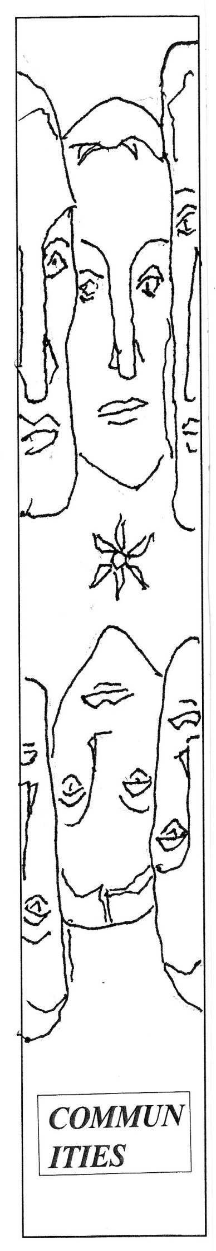
Over time, while this small community of adults builds and strengthens their bonds of friendship, they also deepen their relationship with Christ. They are supported in this process by the adult preparation sessions which are held at a separate time prior to our total community sessions with our friends. While some may question the need for such adult preparation sessions, they play an important role not only in deepening our faith, but are essential to nourish and sustain the communities which provide our friends an opportunity to grow in their faith.

Without the establishment of firm bonds, the group will not be able to adequately support their friends with different abilities in a way that will help them to relate to other members of the community and to grow in faith.

If the SPRED ministry is to flourish in a parish, it must be built upon a solid community of adults. The recent Directory for Catechesis states that “constructive interaction among people establishes the group as a place in which exchange and profound communication blossom. When this is intense and effective, the group is at its best in carrying out its function of supporting the growth of its members.” (#220)

One of our main goals in SPRED is to give our friends with different abilities a sense of community which in turn helps them to develop a sense of the Church. In order to achieve this goal, it is imperative that people with different abilities are welcomed to an established community of adult catechists. It would be unwise to introduce our friends to an inadequately developed adult community. Some communities become so eager to welcome our friends that they prematurely open the door to them. The Directory of Catechesis states that “the Catechist is called to awaken within the group an experience of community as the most coherent expression of the Church’s life.” (#219) The adult catechist will struggle to awaken this sense of community in our friends if they have not had a real and authentic experience of community among themselves.

Building authentic communities of faith has been part of the SPRED mission since the founding of the ministry in the 1960’s. One of the goals of Spred is to develop small communities of faith where both the adult catechists and people with different abilities can experience a profound encounter with Jesus Christ and grow in that relationship. Over the last six decades, SPRED has established hundreds of small communities of faith in parishes throughout the Archdiocese of Chicago and the world. Within these small communities of faith, we are fully present to each other, and we accompany one another on our faith journey. In SPRED we ensure that all our catechists and friends feel welcomed, valued, included and accepted. Through SPRED our friends and catechists are able to develop a deep sense of belonging which is something Pope Francis acknowledges is missing from the lives of many people with different abilities. In his encyclical letter, Fratelli Tutti, he writes that “Many persons with disabilities feel that they exist without belonging and without participating.”(#98) It is our hope that by participating in SPRED our friends no longer feel ostracized, but rather feel that they are valued members of the community.

The idea that our friends are able to develop a sense of belonging has become evident to me throughout my years in Spred. There is no doubt in my mind that people with different abilities and their families in my own Spred group developed a strong sense of belonging within the ecclesial community. Recently I was observing a SPRED session in another parish and I was moved when one of the SPRED friends, who had just been welcomed to the group that evening

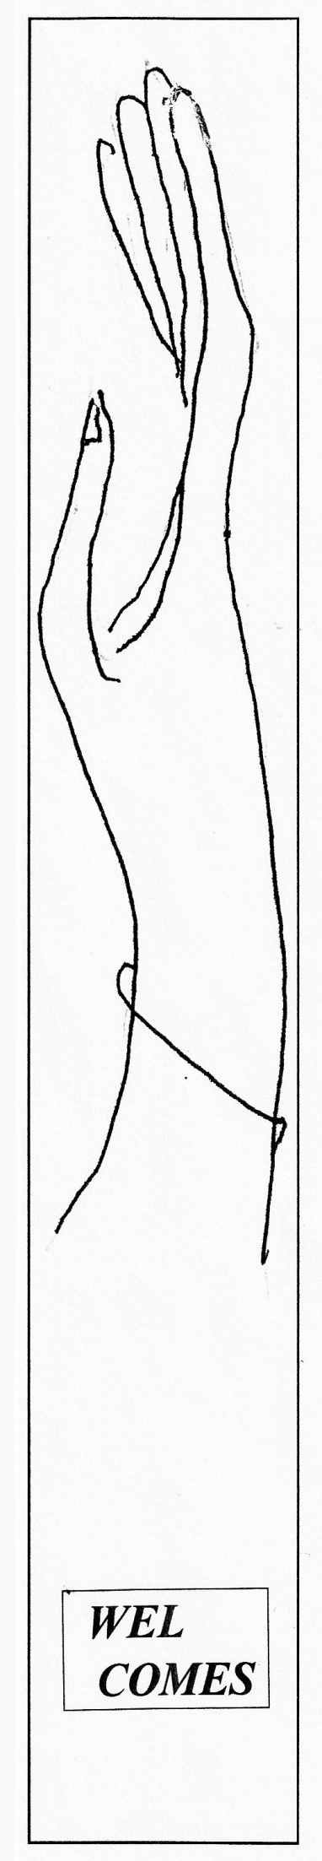
expressed his sincere gratitude for being part of the group. He told the group that he was grateful for all these new friends. Although he was wearing a mask, I could easily tell he had a big smile on his face and was filled with joy throughout the session. I was amazed that he was only in the group this one night and already he had developed a strong sense of belonging.

One term that has been frequently used in Renew My Church discussions is “Radical Hospitality.” Throughout the Renew My Church process the Archdiocese has recognized that our parish communities need to become more welcoming and hospitable toward all people. According to the Archdiocese, parishes need to establish “radical hospitality within a spiritual family that beckons each of us into a community of unconditional love and authentic caring, with a particular heart for those who are struggling, lost, or alone.”

The experience of disengagement from my parish personally resonates with me. There was a moment in my early twenties when I felt that I was on the verge of becoming disengaged from my parish community. While I attended mass each week, I did not have a meaningful engagement with any members of the community. I felt as though my faith life had lost a communal aspect and had become purely individualistic. I decided that I would make an effort to enhance my communal life by getting involved in a ministry. I ended up joining SPRED and it was through SPRED that I rediscovered the communal aspect of my faith. Through this small community of faith made up of adult catechists and people with different abilities, my spiritual life was renewed.

Archdiocesan research also suggests that another key factor that causes people to disengage from their parishes is the lack of an intense and profound encounter with Jesus Christ. Not only did Spred help me to develop a strong sense of community and belonging, but Spred also helped me to develop a stronger and deeper relationship with Christ. Through Spred, the factors that have led people to disengage from their parishes were addressed and I no longer felt disengaged from my parish community and my spiritual life had been renewed.

Every time I hear the term ‘radical hospitality’ I cannot help but think of SPRED. One way a parish can convey radical hospitality is by establishing a SPRED ministry in their parish. They can then be ready to welcome people with different abilities who have been overlooked by our parish communities.

Radical hospitality also extends outside of our local SPRED communities to other aspects of the ministry. When a person attends a SPRED event, whether a SPRED family liturgy, a SPRED information session, or SPRED training session, that person will without a doubt have an experience of radical hospitality.

Our animation team members, hospitality team members, and trainers warmly welcome all interested volunteers, catechists, parents, and family members to all our events. We take special care to acknowledge each person and fervently work to foster relationships among all the attendees.

Through SPRED, our friends with different abilities and catechists are able to develop a strong sense of community and belonging which helps them to deepen and grow in their relationship with Christ. SPRED is a ministry that embodies radical hospitality and can play a pivotal role in Renew My Church process. Joseph Quane
Director, Spred Chicago

Chicago Spred Calendar

TRAINING/ORIENTATION  Orientation: Feb. 12, 19, 26, 2022  Roles: March 12, 19, 2022  Spred Center, 30th and S. Lowe. Ave.  Contact: Mary Ward, 312-842-1039 x 211  SPREDWEAR:  T-shirts, bags, caps, pullovers, masks.  maryward@archchicago.org | OBSERVATION  Queen of Apostles: Tues, Wed, Thurs.  4412 N. Western, Chicago. Contact: Julia Hess.  www.queenofangelsspred.org/observation.html  773-539-7510  REFLECTION WEEKEND  January, 7, 8 y 9, 2022. Contact: Julia Hess.  www.queenofangelsspred.org/reflection-weekend.html

