SPRED
SPECIAL RELIGIOUS DEVELOPMENT
2956 South Lowe Ave. Chicago, Illinois 60616
Special 312-842-1039 www.spred-chicago.org
__________________________________________________________________________________________

September 2020 Volume 99 Number 1

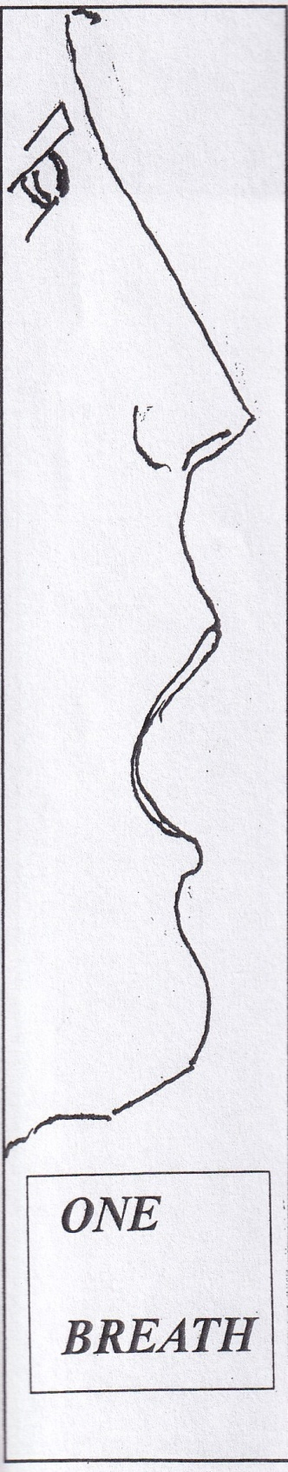
I sat comfortably on a chair with my hands resting on my lap. I felt I was dwelling in silence and I noticed my senses focused on my breathing. I inhaled. I felt the air coming in through my nostrils. I exhaled. I released air through my mouth. I marveled at the mystery of human respiration where breathing transforms the air flowing in and out of my lungs. As I breathe, oxygen comes in and it goes out as carbon dioxide. This natural human activity produces energy for our bodies. It keeps us alive and sustains our existence; it is a life-giving creation by an almighty and loving Creator, the One “who gives breath to everyone, life to everyone who walks the earth.” (Isaiah 42:5)

I pondered on a moving experience which happened with my friends during one of our Spred sessions. It was a moment when our group encountered not an ordinary quietness but a peculiar stillness among us. Unexpectedly, each of us could hear the others taking a deep breath. I was deeply moved and touched by such an experience for it happens rarely in our faith community. Our breathing together was imbued with a sense of harmony and calmness. We remained still and let ourselves breathe. The two-staged dynamic of breathing, inhaling and exhaling, moved us to wandering. Even though we did not go anywhere, we journeyed as pilgrims passing along a path from a boisterous to a tranquil ground. The momentary experience of deep awareness of our breathing fed and nourished our spiritual lives. As human creatures, our breathing was our act of praise to God, our Creator.

I miss being with my life-giving Spred faith community. I ask myself when I can be with my friends and catechists again? We have been in an unprecedented time for half a year now due to the coronavirus pandemic. The unchartered territory we are living in seems to deprive us of our freedom to breathe. We have become more conscious of our breathing. Those who are safe and healthy appreciate and safeguard their breathing by social distancing and wearing masks. Those who are infected with COVID-19 are fighting for their lives by isolating themselves in hospitals with the support of ventilators. It is absolutely the opposite condition from what happened in that Spred celebration room. It is excruciating to see the COVID-19 patients being deprived of their breathing.

Breathing is for all. According to statistics African-Americans and other people of color are dying at higher rates from COVID-19 in the United States. We hear the anguish of people, particularly those infected by the virus, “I can’t breathe.” Along with the pain and sadness caused by the virus, we also have been afflicted by social unrest due to racial injustice. The expression “I can’t breathe” has been the cry of those who have demonstrated for greater respect and better lives. They want to be treated justly, to be accepted and respected regardless of race or skin color. They want to breathe freely.
It is a grace to witness and experience our friends’ breathing in our Spred community. They breathe the spirit of friendship, acceptance, patience, kindness, love, joy, compassion and peace. We let them breathe regardless of their color, race, or disability. Our breathing serves as our connection and our intimacy grows and is nurtured when we are together. We breathe for others and with others. Like frontliners selflessly serving the victims of COVID-19 and like social justice advocates untiringly fighting for racial equality, we, in our Spred community are called to uphold and protect the right to life, social protection, and equality that our friends deserve.

Let us hold on to those moments during our Spred sessions when we breathe together. Let the meaningful sessions we have had with our friends be a reminder for us that they are not invisible, they are present everywhere and in our parish communities.

Although it is important for the safety of everyone that we follow the guidelines for our health, these guidelines cannot lead us to begin to treat our friends as objects. They are humans. They should not be manipulated, controlled, deprived or enslaved. They are made for life with others. They are present to live in a society where they will breathe freely and lovingly. When we focus only on our own needs and comfort, intentionally or unintentionally, we could fall into a strong temptation to disregard, ignore, forget, isolate, discriminate and reject our ministry to our friends and our commitment to be friends. What makes our Spred group a faith community is our communion and unity, where each recognizes their life-giving role in service of the community. We remind ourselves that the Spred community in our parish is the first place for personal human encounter that our friends will have with the face of the Church 1

In collaboration with our parish community and our friends’ families, we serve as faith responders who ensure adequate spiritual, emotional, and social support for our friends as well as their families. We breathe with and for our friends by accompanying them on their Christian faith journey and protecting their rights as human beings. A renewed and generous commitment to service in the mission of evangelization is important. We are each called to place ourselves at the service of the Spred community.

Many of us have been taking initiatives and making efforts at finding creative ways to deliver and sustain our Spred ministry in the midst of the pandemic. In the past months, a series of online gatherings were conducted and participated in by many catechists where they shared information about their current conditions and the challenges in the parish’s Spred ministry. Our ministry has not been spared from the effects of the pandemic. Many of our friends, catechists and others have expressed their fears, limitations, and uncertainties. Many individuals are vulnerable to infection and they need to be protected. Everyone recognizes the tremendous difficulty to follow social distancing and observe hygiene precautions among our friends during the sessions. The Spred method involves human connections emotionally, spiritually and physically. It entails a high degree of close bodily contact. Some chairpersons said that they lost their meeting space or room when their parish needed their space. There are friends who leave the vicinity and reside in facilities that would be safer for them. Several catechists have expressed the decision to discontinue their service in Spred due to health reasons.
Undeniably, it is overwhelming to absorb all the pressing concerns. In our uncertainty we have to catch our breath. But we still have to ponder our future as changes develop. We need to work together to discern our future.

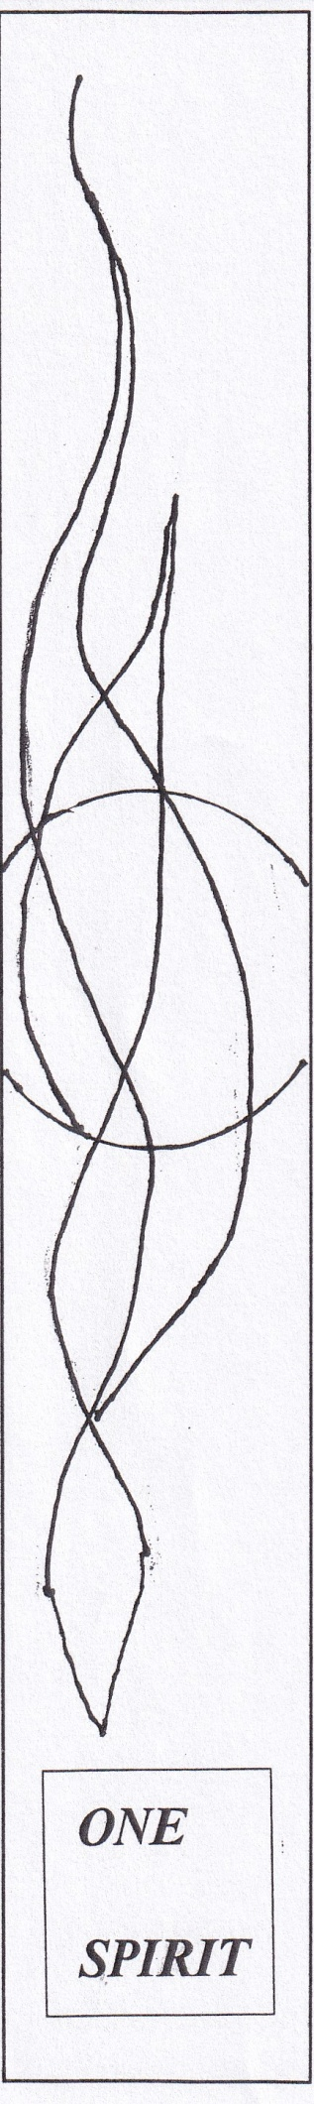
Our Spred community is a family of missionary disciples (catechists, friends, parents, pastors), who by virtue of Baptism and other Sacraments of Christian Initiation, are called to serve in the ecclesial community for its growth and life. “In order for the journey of the Word to continue, the Christian community must make a determined missionary decision capable of transforming everything, so that the Church’s customs, ways of doing things, times and schedules, language and structures can be suitably channeled for the evangelization of today’s world rather than for her self-preservation.”2

While our faith community could not gather at our parish (hopefully just temporarily), it is necessary to find alternative and temporary approaches to get closer to our friends and be able to accompany them during this period.

It is the kind of task that “ought not to be seen as a burden, but rather as a challenge to be embraced with enthusiasm”3 It is impossible to pursue this endeavor without personal encounter with the living Word of God among us: “When you give them your breath, life is created, and you renew the face of the earth.” (Psalm 104:30)

In times of pandemic, we breathe together through our ordinary and extraordinary ways of giving pastoral care to our faith community, most especially our friends. Empowered by Christ’s Spirit, let us enrich our faith community by fostering a “culture of encounter”4 and mastering the “art of accompaniment.”5 This will deepen our friendships. Let us continue our collaboration as we embrace the Holy Spirit’s invitation to be transformed in the process of “renewing” the face of our ministry. Rev. Marlon Bobier Vargas, SVD
Spred Chicago

Dear Spred community, I would like to express my deep joy and gratitude for your significant and priceless contribution to my pastoral and spiritual formation over the past years in becoming a religious-missionary priest. On August 15, 2020 I was ordained as a religious priest for the Society of the Divine Word. Part of that milestone is my recently self-published book entitled: The Roundabouts of Life: A Journey of a Soul on a Mission. It is a compilation of stories and reflections about my experiences with the people whom I encountered throughout my vocational journey. The book is available at a suggested donation of $20.00 each (including shipping fees). The proceeds will be for the benefit of Mamre Inc. If you would like to order a copy, kindly make your request through my email (marlonbobiervargas@gmail.com) or mobile number (312-383-9177).

Please make your check donation payable to Mamre Inc. and send it to the Spred Center at 2956 South Lowe Ave. Chicago IL 60616, USA. Your copy will be shipped once your check is received. Your generosity will be deeply appreciated and gratefully acknowledged.
Fr. Marlon
The Spred community in Chicago thanks Fr. Marlon for his ministry with us as a leader and helper catechist. We offer our blessings, congratulations and very best wishes to him on his ordination. We regretfully say good-bye to him as he sets off to work in Spain.

1. Instruction ‘The Pastoral Conversion of the Parish Community in the Service of the Evangelizing Mission of the Church’ Congregation for the Clergy,” para, 33, https://press.vatican.va/content/salastampa/en/bollettino/pubblico/2020/07/20/200720.
2. “Instruction ‘The Pastoral Conversion of the Parish Community in the Service of the Evangelizing Mission of the Church’ of the Congregation of the Clergy” para.5, 3. Ibid. para.14, 4. Ibid, para.25, 5.Ibid. para.26

